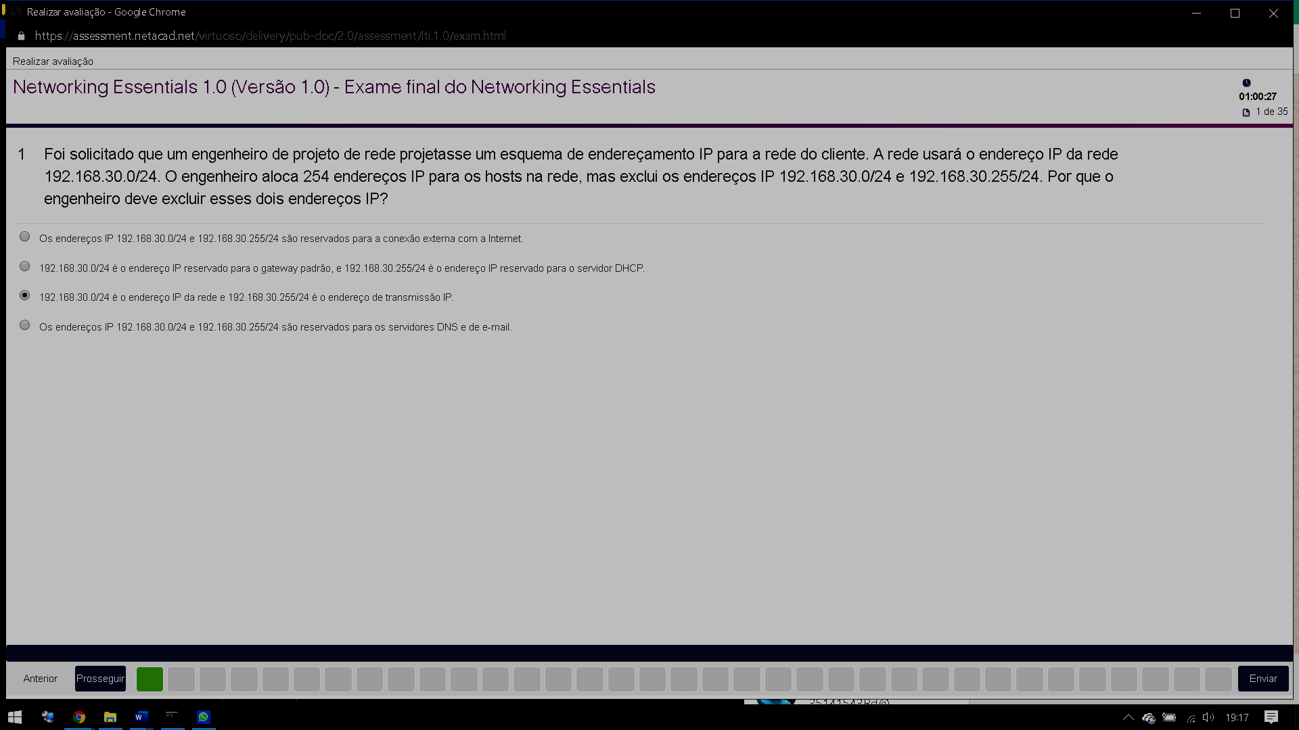

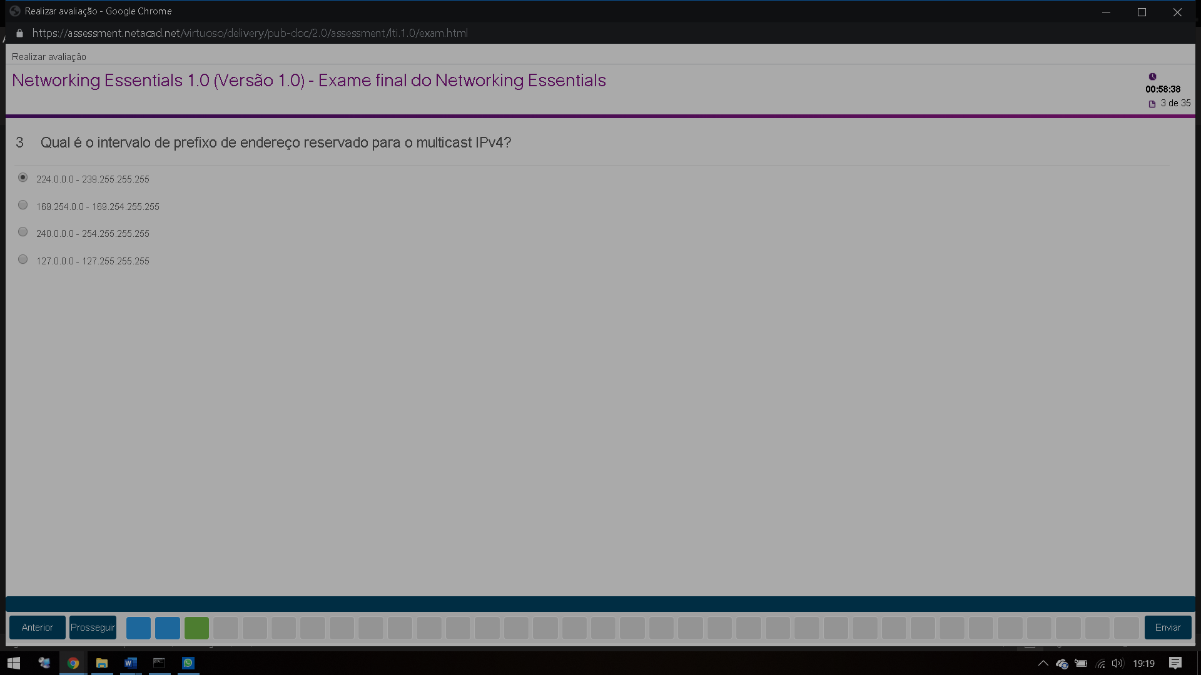

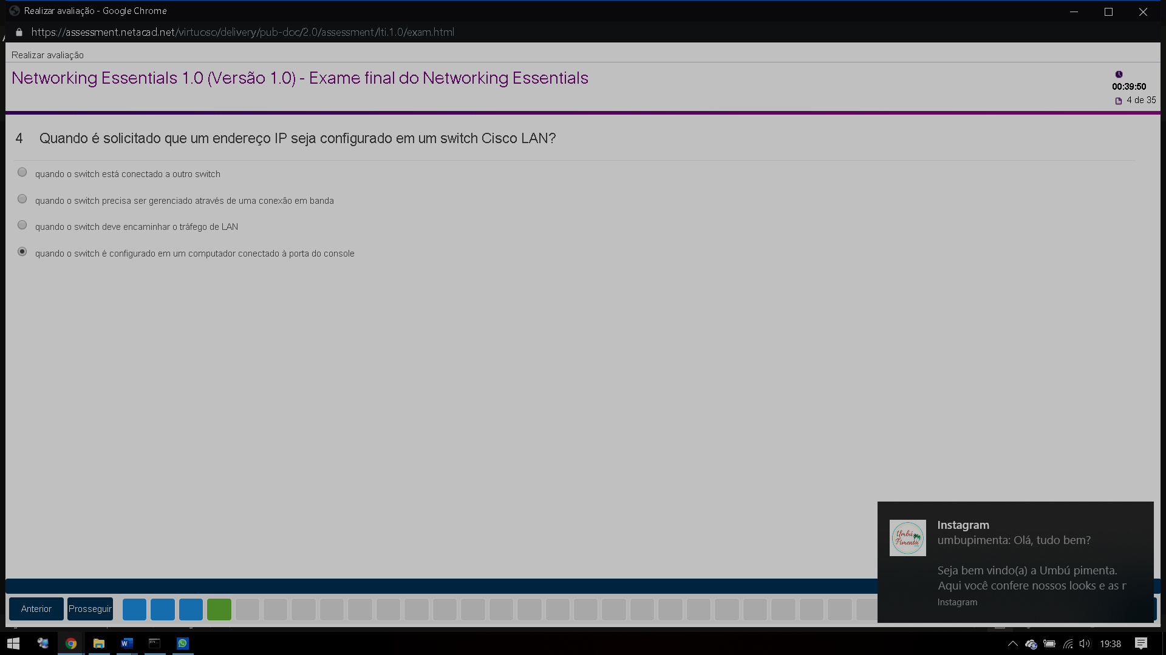

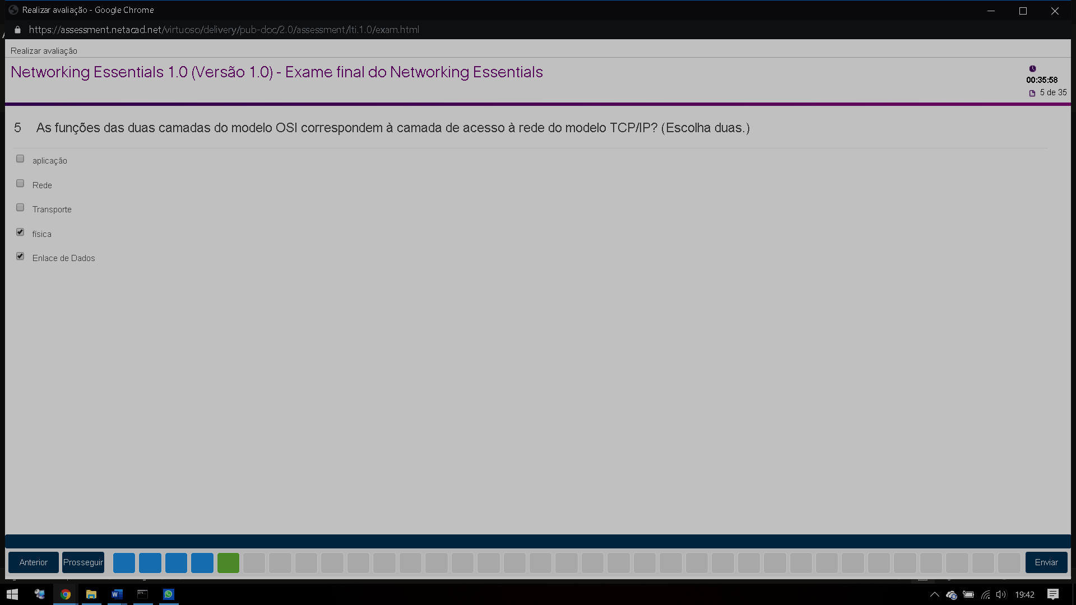

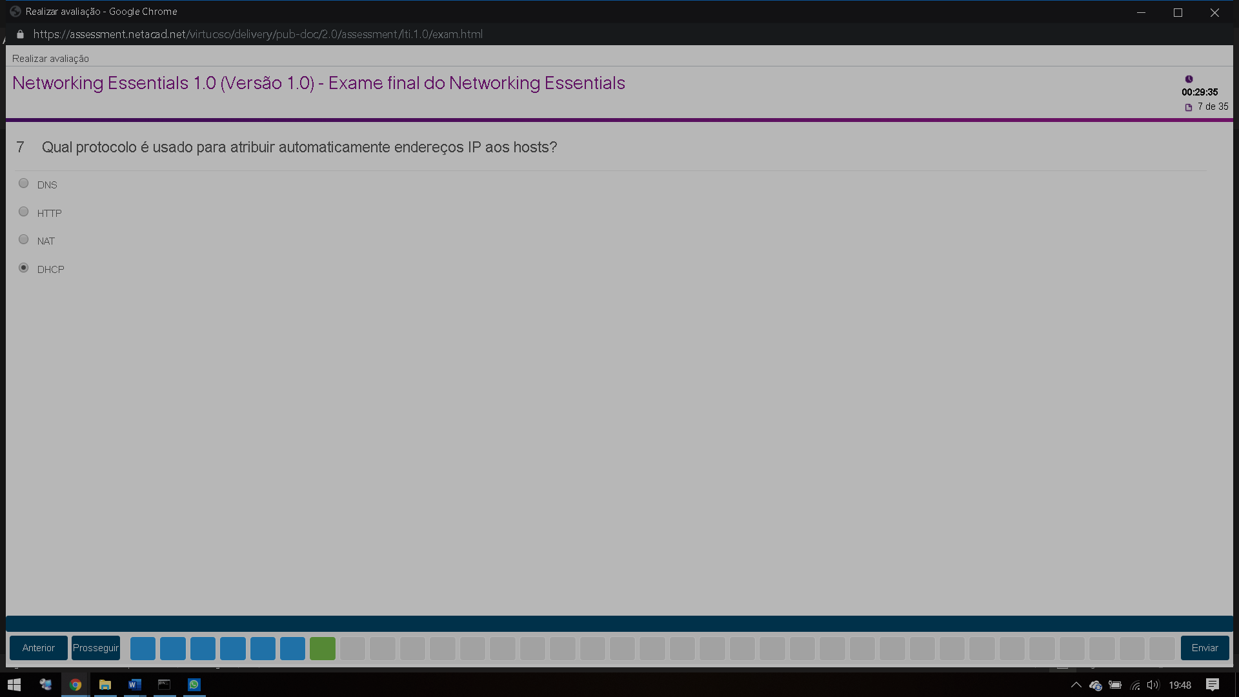

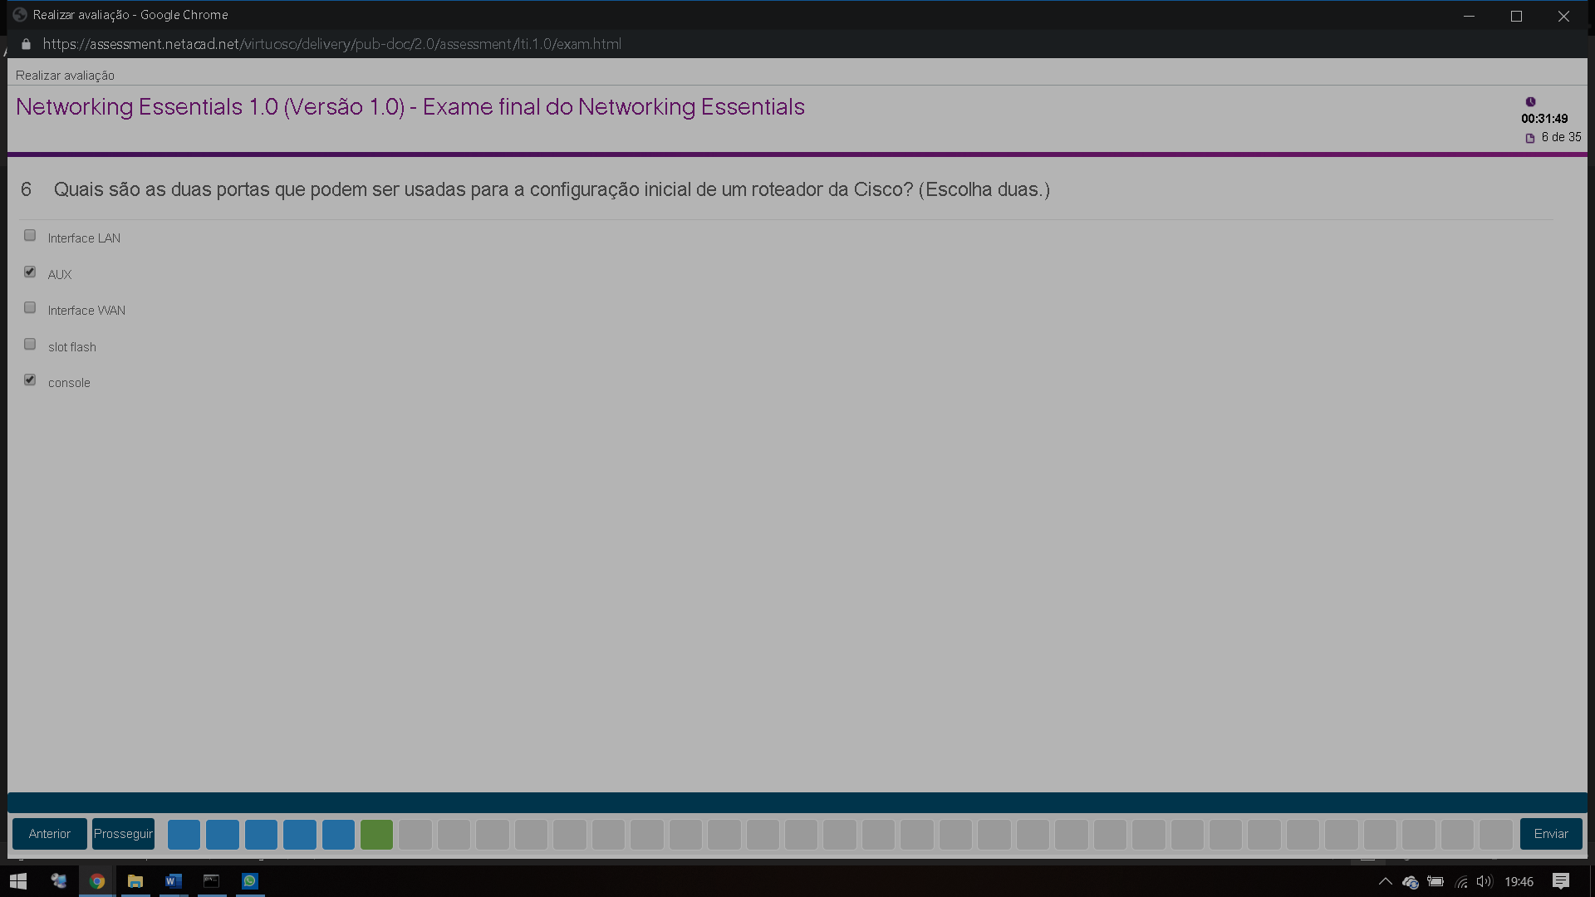

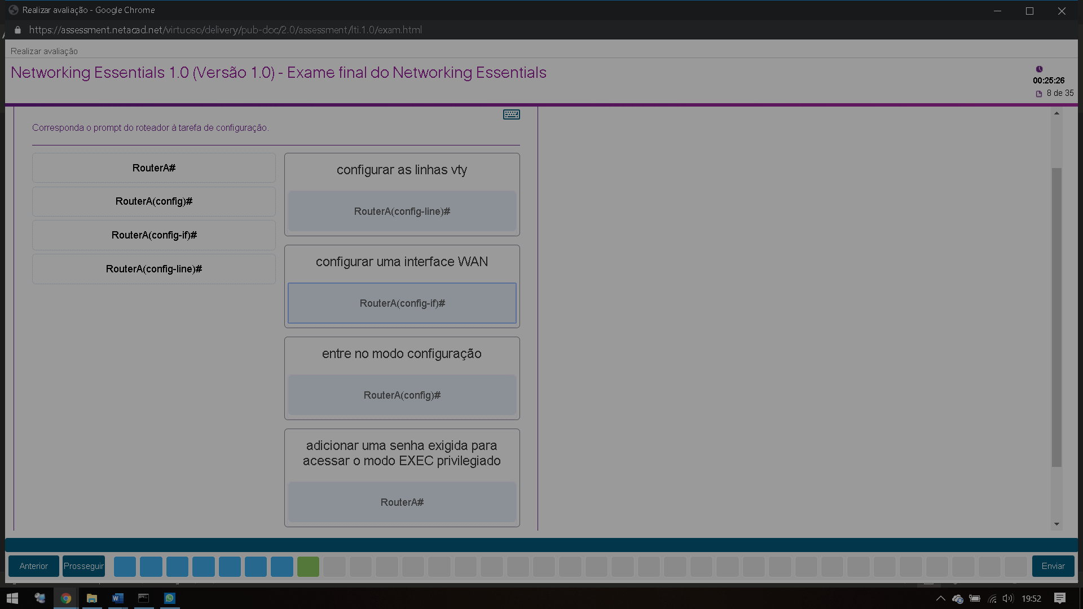

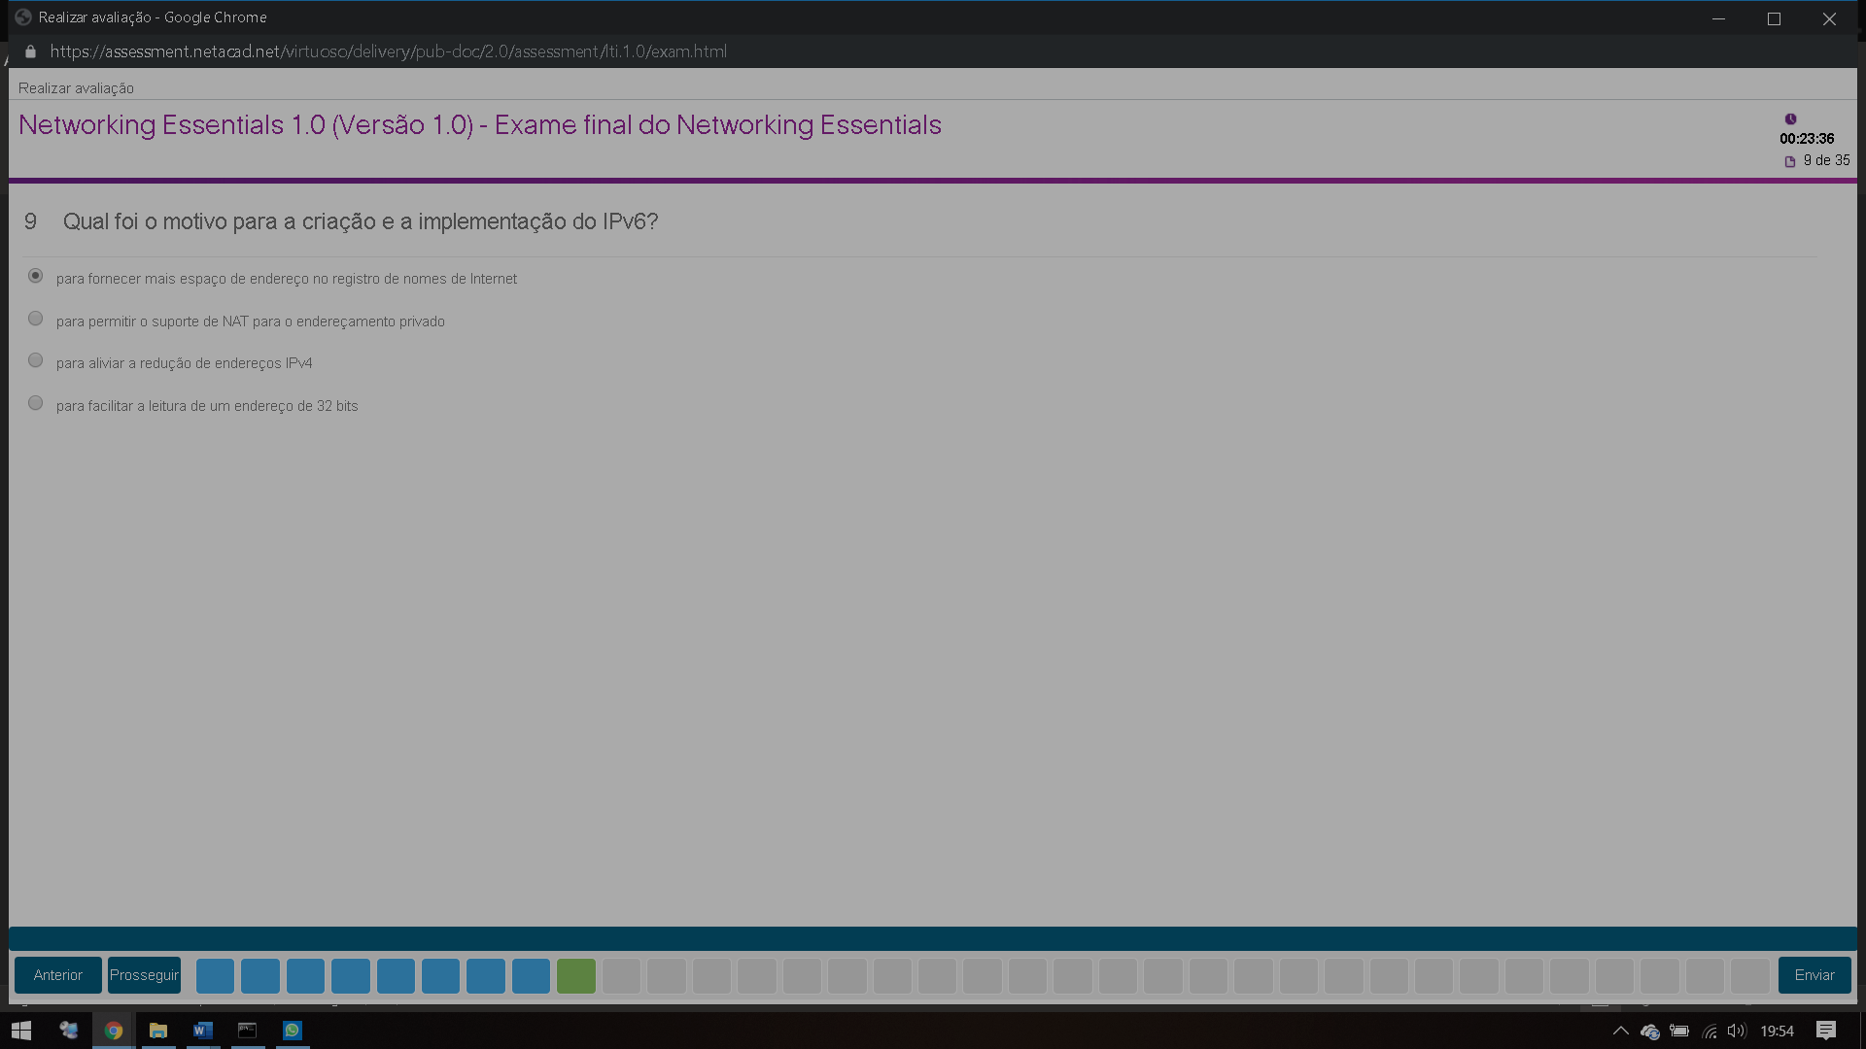

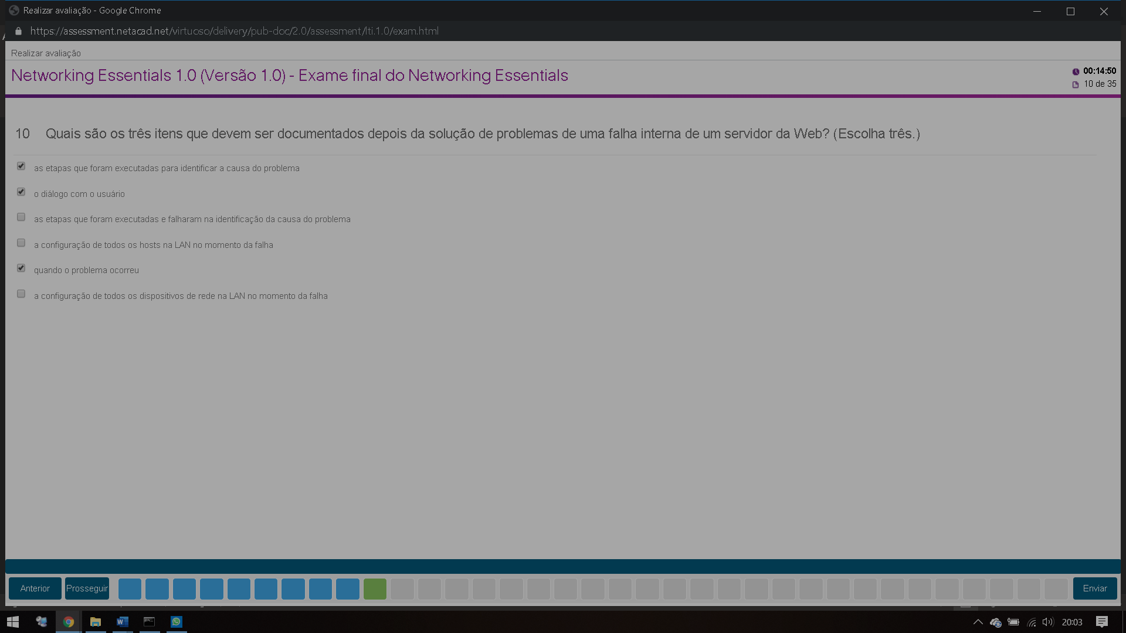

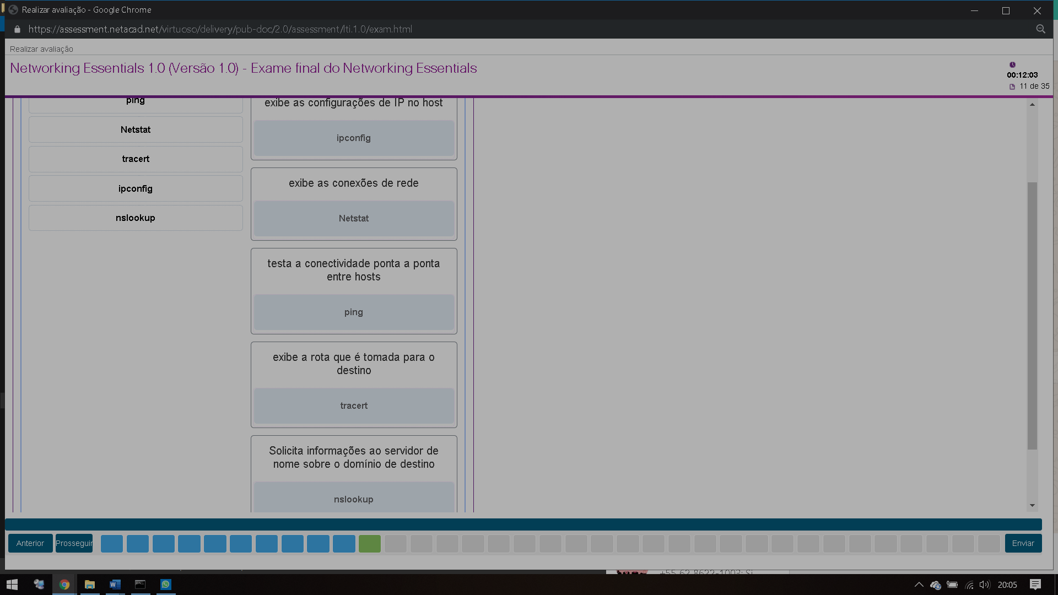

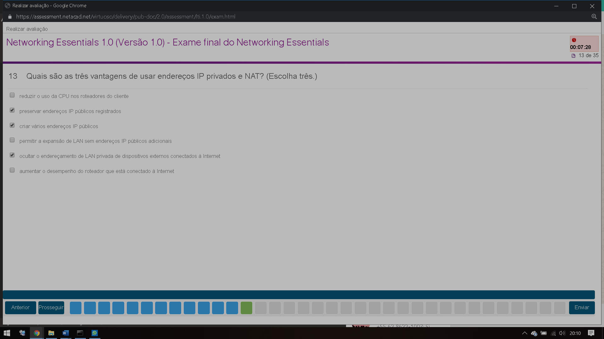

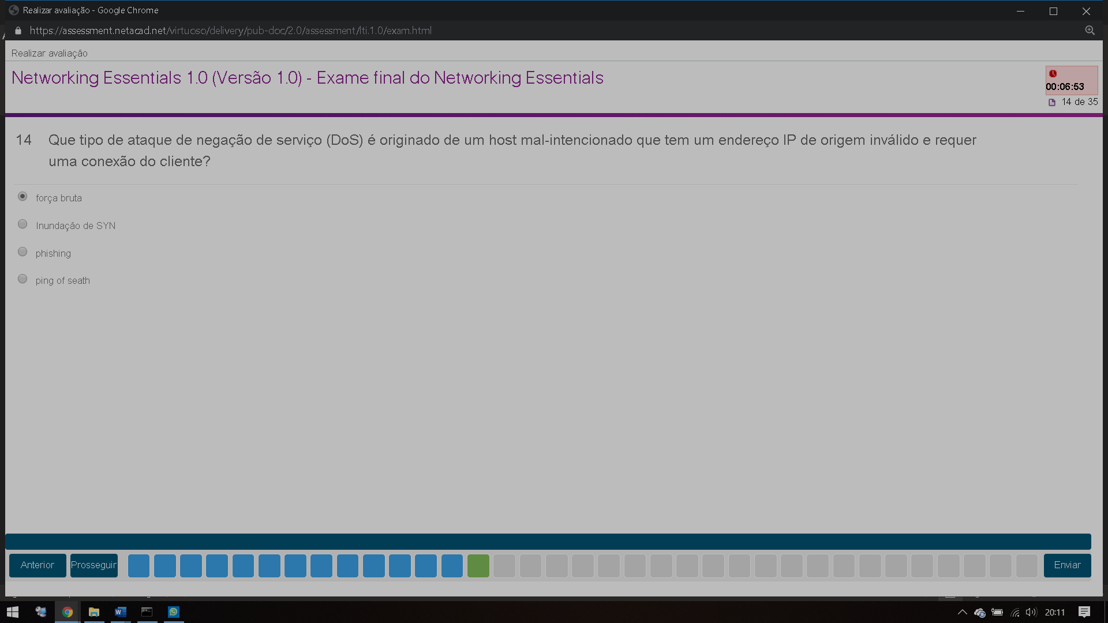

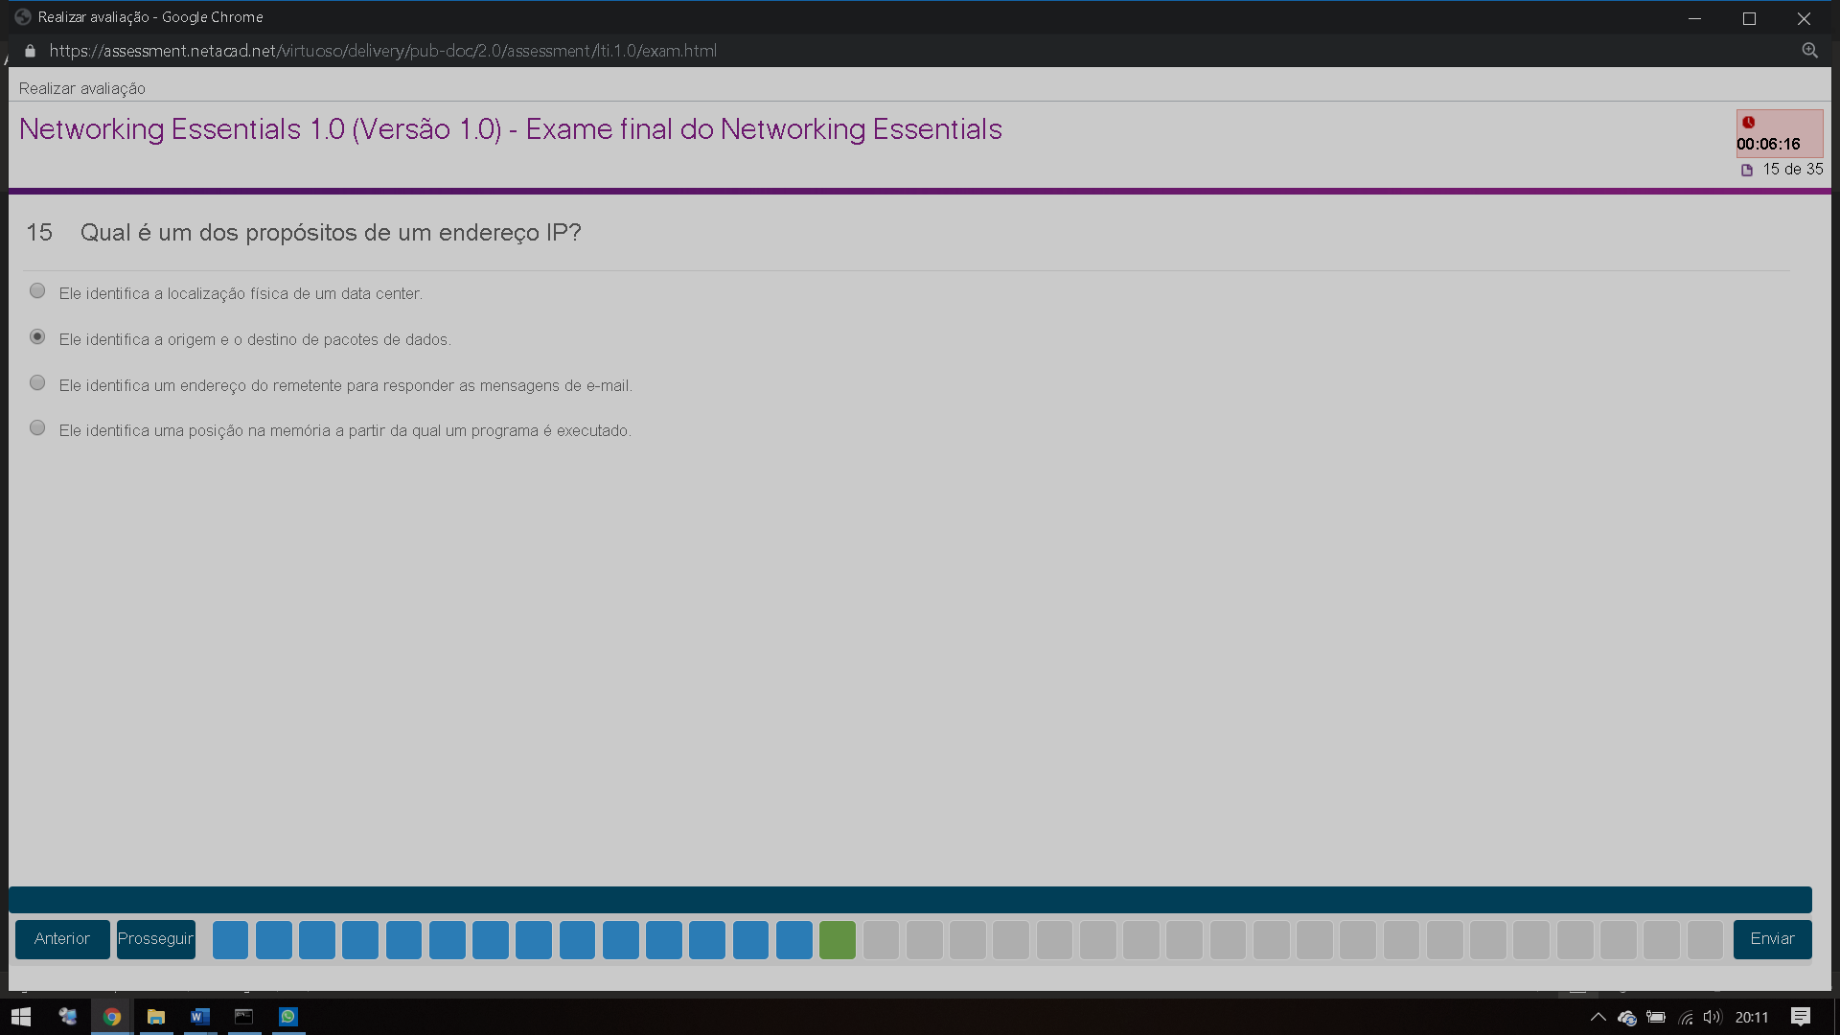

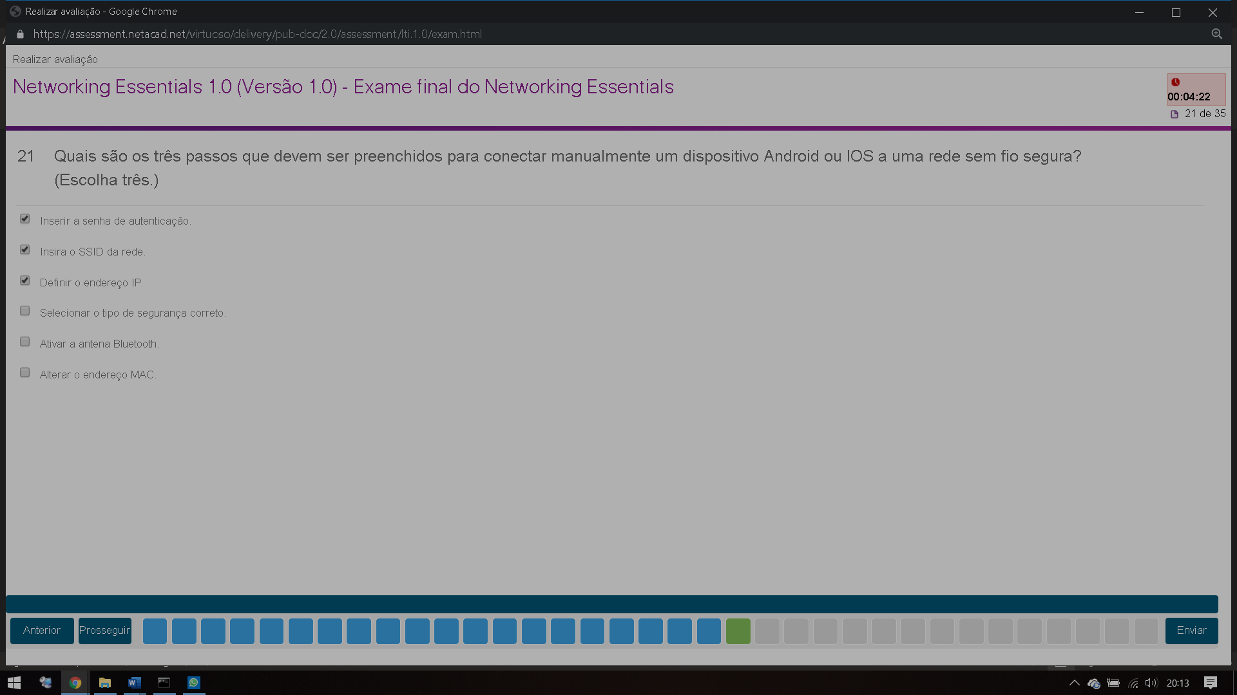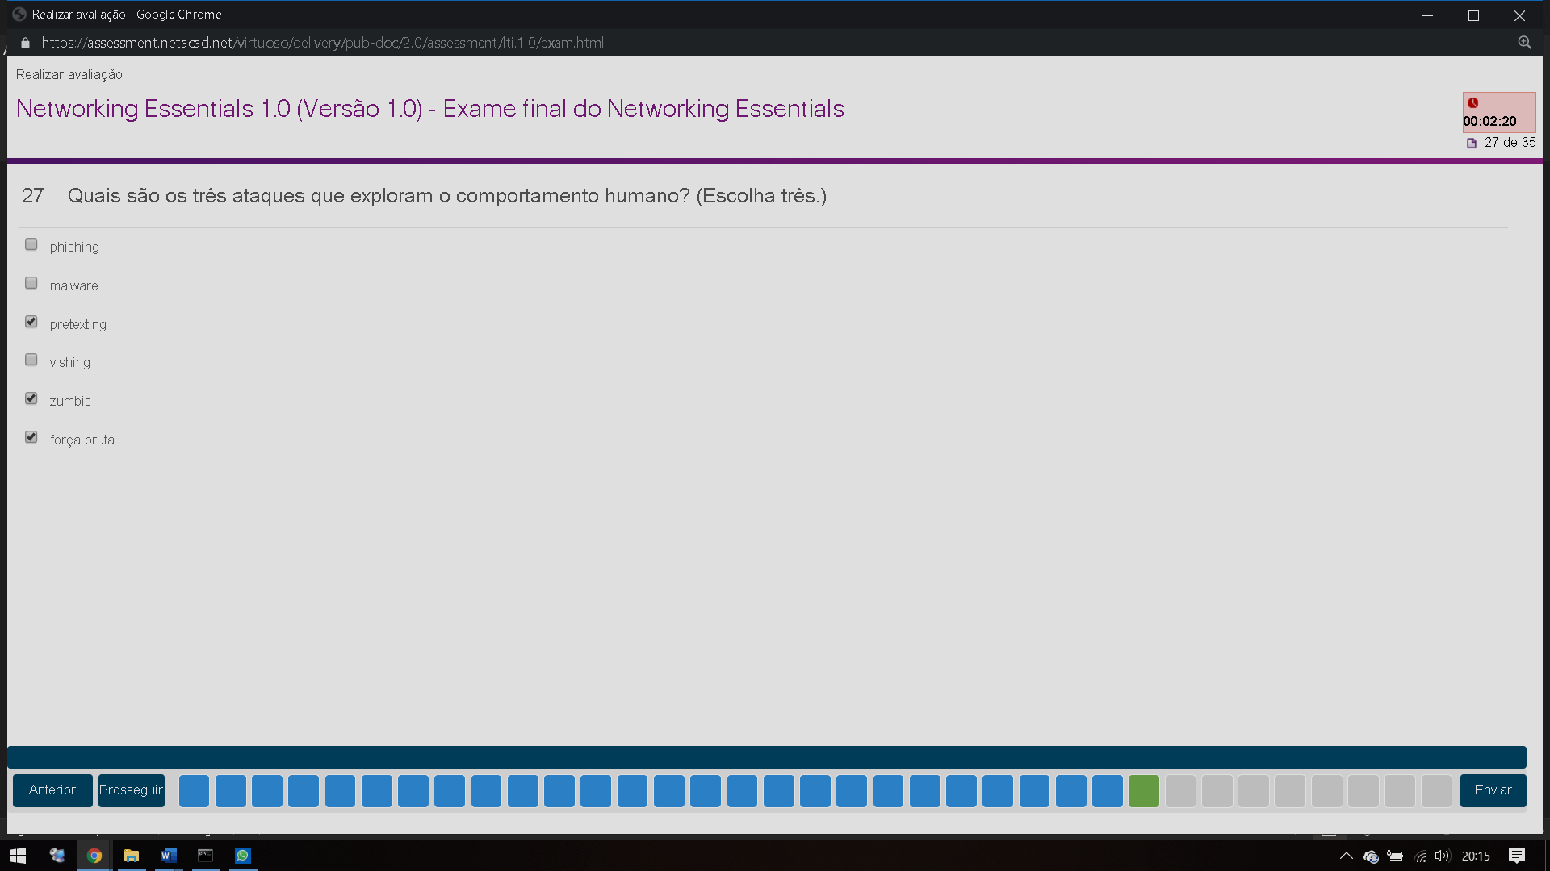

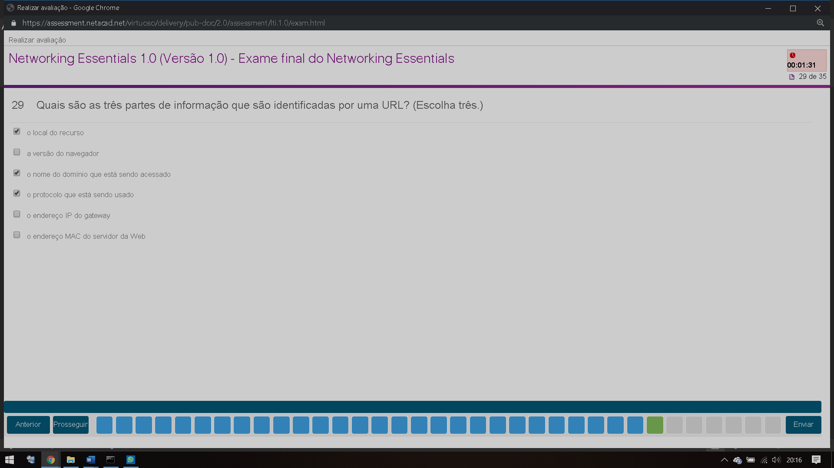

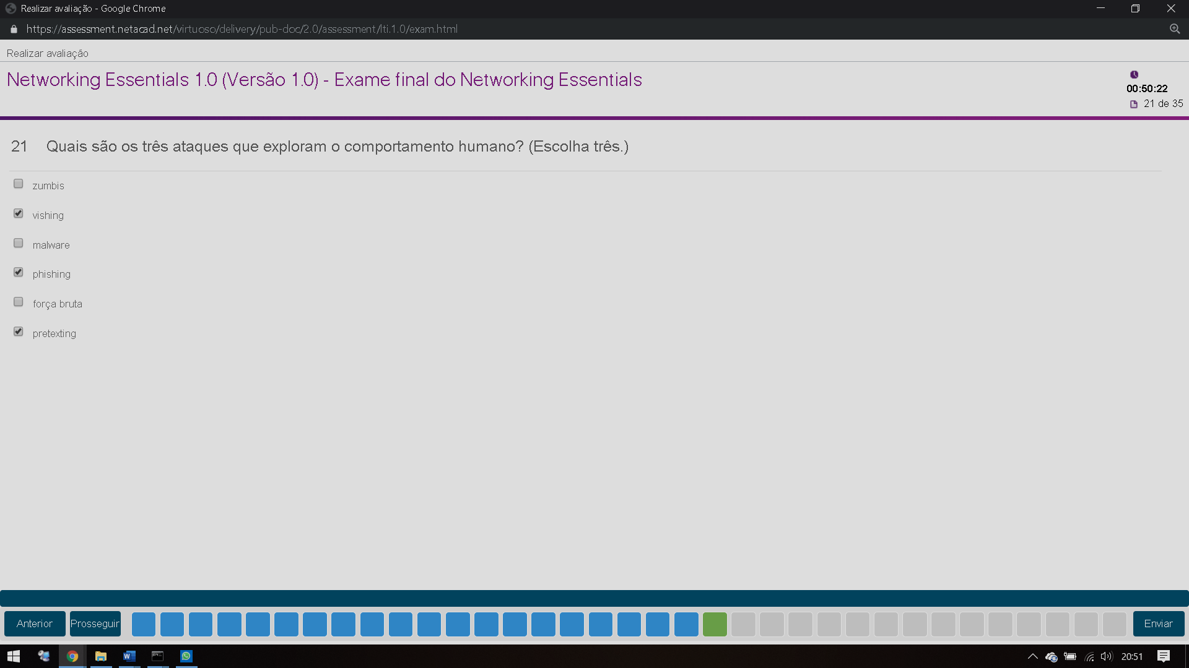

## Networking Essentials Final Exam Answers Full 100% 2019

1. **What is a disadvantage of deploying a peer-to-peer network model?**
   * difficulty of setup
   * lack of centralized administration
   * high degree of complexity
   * high cost

|  |
| --- |
| * + **Explanation:**   + The simplest peer-to-peer network consists of two computers that are directly connected to each other through the use of a wired or wireless connection. The primary disadvantages of a peer-to-peer network are its lack of central administration, minimal security, and its lack of scalability. |

1. **What is a purpose of an IP address?**
   * It identifies the physical location of a data center.
   * It identifies a location in memory from which a program runs.
   * It identifies a return address for replying to email messages.
   * It identifies the source and destination of data packets.

|  |
| --- |
| * + **Explanation:**   + Packets that are routed across the Internet contain source and destination IP addresses. These addresses are used to determine how the packets should be routed from source to destination by intermediate devices. |

1. **A consumer places a smartphone close to a pay terminal at a store and the shopping charge is successfully paid. Which type of wireless technology was used?**
   * Bluetooth
   * NFC
   * Wi-Fi
   * 3G

|  |
| --- |
| * + **Explanation:**   + NFC is a wireless technology that allows data to be exchanged between devices that are in very close proximity to each other. |

1. **Which type of network cable is commonly used to connect office computers to the local network?**
   * coaxial cable
   * twisted-pair cable
   * glass fiber-optic cable
   * plastic fiber-optic cable

|  |
| --- |
| * + **Explanation:**   + Twisted-pair is a type of copper cable used to interconnect devices on a local network. |

1. **What are two advantages of using fiber-optic cabling to interconnect devices? (Choose two.)**
   * Fiber-optic cable is immune from EMI and RFI.
   * Fiber-optic cables can extend several miles.
   * Fiber-optic cables use extra shielding to protect copper wires.
   * Fiber-optic cables are easy to install..
   * Fiber-optic cables are commonly found in both homes and small businesses.

|  |
| --- |
| * + **Explanation:**   + Fiber-optic cables provide immunity to both EMI and RFI and a single cable can extend for several miles before regeneration is needed. |

1. **The functions of which two layers of the OSI model are matched to the network access layer of the TCP/IP model? (Choose two.)**
   * application
   * physical
   * transport
   * network
   * data link

|  |
| --- |
| * + **Explanation:**   + The application layer of the TCP/IP model is composed of the application, presentation, and session layers of the OSI model and is used by network applications to complete specific tasks. The network access layer of the TCP/IP model is composed of the physical and data link layers of the OSI model and describes how a device accesses and sends data over the network media. |

1. **What is the minimum size of a valid Ethernet frame?**
   * 48 bytes
   * 64 bytes
   * 96 bytes
   * 128 bytes

|  |
| --- |
| * + **Explanation:**   + Ethernet standards define a frame with a minimum of 64 bytes and a maximum of 1518 bytes including fields of destination MAC address, source MAC, Length/Type, data payload, and FCS. |

1. **A network design engineer has been asked to design the IP addressing scheme for a customer network. The network will use IP addresses from the 192.168.30.0/24 network. The engineer allocates 254 IP addresses for the hosts on the network but excludes 192.168.30.0/24 and 192.168.30.255/24 IP addresses. Why must the engineer exclude these two IP addresses?**
   * 192.168.30.0/24 and 192.168.30.255/24 IP addresses are reserved for the email and DNS servers.
   * 192.168.30.0/24 and 192.168.30.255/24 IP addresses are reserved for outside Internet connectivity.
   * 192.168.30.0/24 is the network IP address and 192.168.30.255/24 is the IP broadcast address.
   * 192.168.30.0/24 is the IP address reserved for the default gateway, and 192.168.30.255/24 is the IP address reserved for the DHCP server.

|  |
| --- |
| * + **Explanation:**   + The IPv4 addressing system is a hierarchical addressing system. An IPv4 address is made up of two parts, the network address and the host address. When the host portion is all “0s” in binary, it is designated as a network address. When the host portion is all “1s” in binary, it is designated as a broadcast address. These two addresses cannot be assigned to individual hosts. |

1. **Which protocol is used to automatically assign IP addresses to hosts?**
   * DNS
   * NAT
   * DHCP
   * HTTP

|  |
| --- |
| * + **Explanation:**   + DHCP, or Dynamic Host Configuration Protocol, is used to automatically assign IP addresses to hosts that are configured as DHCP clients.​ |

1. **What are three advantages of using private IP addresses and NAT? (Choose three.)**
   * conserves registered public IP addresses
   * reduces CPU usage on customer routers
   * creates multiple public IP addresses
   * hides private LAN addressing from outside devices that are connected to the Internet
   * permits LAN expansion without additional public IP addresses
   * improves the performance of the router that is connected to the Internet

|  |
| --- |
| * + **Explanation:**   + Private IP addresses are designed to be exclusively used for internal networks and they cannot be used on the Internet. Thus they are not visible directly from the Internet and they can be used freely by network administrators for internal networks. In order for the internal hosts to access the Internet, NAT is used to translate between private and public IP addresses. NAT takes an internal private IP address and translates it to a global public IP address before the packet is forwarded. |

1. **What was the reason for the creation and implementation of IPv6?**
   * to make reading a 32-bit address easier
   * to relieve IPv4 address depletion
   * to provide more address space in the Internet Names Registry
   * to allow NAT support for private addressing

|  |
| --- |
| * + **Explanation:**   + IPv4 addressing space is exhausted by the rapid growth of the Internet and the devices connected to the Internet. IPv6 expands the IP addressing space by increasing the address length from the 32 bits to 128 bits, which should provide sufficient addresses for future Internet growth needs for many years to come. |

1. **Which three pieces of information are identified by a URL? (Choose three.)**
   * the MAC address of the web server
   * the protocol that is being used
   * the domain name that is being accessed
   * the IP address of the gateway
   * the version of the browser
   * the location of the resource

|  |
| --- |
| * + **Explanation:**   + URLs are used to access specific content on a web server through a web browser. The URL identifies the protocol that is being used such as HTTP or FTP, the domain of the server, and the location of the resource on the server. |

1. **Which protocol is used by web servers to serve up a web page?**
   * FTP
   * HTTP
   * IMAP
   * POP

|  |
| --- |
| * + **Explanation:**   + Hypertext Transfer Protocol (HTTP) is a protocol that is used by web servers to serve up a web page.​ |

1. **Why do streaming audio and video applications use UDP instead of TCP?**
   * Streaming audio and video applications require receipt of all packets regardless of delay.
   * The three-way handshake used in UDP speeds up the audio and video streams.
   * Streaming audio and video applications cannot tolerate the delay caused by retransmission.
   * UDP provides guaranteed segment delivery to provide reliable audio and video streams.

|  |
| --- |
| * + **Explanation:**   + UDP is a ‘best effort’ delivery system that does not require acknowledgment of receipt and is the preferred transport service for streaming audio and video. UDP provides low overhead and does not implement as much delay as TCP. Streaming audio and video cannot tolerate network traffic congestion and long delays. |

1. **At which layer of the TCP/IP model does TCP operate?**
   * transport
   * application
   * internetwork
   * network access

|  |
| --- |
| * + **Explanation:**   + TCP is the Transmission Control Protocol and it operates at the transport layer of the TCP/IP model. TCP ensures that IP packets are delivered reliably. |

1. **Which protocol is used to transfer web pages from a server to a client device?**
   * HTML
   * SMTP
   * HTTP
   * SSH
   * POP

|  |
| --- |
| * + **Explanation:**   + The Hypertext Transfer Protocol (HTTP) provides services between a web browser requesting web pages and a web server responding to the requests. HTML (Hypertext Markup Language) is a markup language to instruct a web browser how to interpret and display a web page. |

1. **Which type of device filtering can be enabled on some wireless access points or wireless routers?**
   * authentication
   * IP address
   * user ID
   * MAC address

|  |
| --- |
| * + **Explanation:**   + On wireless access points, MAC addresses can be manually entered to filter which devices are allowed on the wireless network. |

1. **Which technology is used to uniquely identify a WLAN network?**
   * MAC address table
   * SSID
   * WEP
   * WPA

|  |
| --- |
| * + **Explanation:**   + When a wireless AP or router is being set up, an SSID is configured to uniquely identify the WLAN that is managed by the device. |

1. **What type of Internet connection would be best for a residence in a remote area without mobile phone coverage or wired connectivity?**
   * dial-up
   * cellular
   * satellite
   * DSL

|  |
| --- |
| * + **Explanation:**   + Satellite Internet service provides the best option for a home user that would otherwise have no Internet connectivity at all. Cellular Internet is only available in areas with mobile phone coverage. |

1. **Which advanced wireless security measure allows a network administrator to keep sensitive data secure as it travels over the air in a wireless network?**
   * encryption
   * authentication
   * traffic filtering
   * MAC address filtering

|  |
| --- |
| * + **Explanation:**   + Encryption is used to secure plaintext data that would be viewable traveling over a wireless network. |

1. **Which three steps must be completed to manually connect an Android or IOS device to a secured wireless network? (Choose three.)**
   * Input the authentication password.
   * Enter the network SSID.
   * Choose the correct security type.
   * Set the IP address.
   * Activate the Bluetooth antenna.
   * Change the MAC address.

|  |
| --- |
| * + **Explanation:**   + In order to connect an Android or IOS device to a Wi-Fi network manually, perform these steps:     - Enter the network SSID of the wireless network.     - Choose the security type used by the wireless network.     - Input the password to authenticate successfully. |

1. **Which three attacks exploit human behavior? (Choose three.)**
   * pretexting
   * brute force
   * phishing
   * zombies
   * vishing
   * malware

|  |
| --- |
| * + **Explanation:**   + Attacks aimed at exploiting human behavior such as pretexting, phishing, and vishing are commonly used by hackers to obtain information directly from authorized users.​​ |

1. **Which address prefix range is reserved for IPv4 multicast?**
   * 240.0.0.0 – 254.255.255.255
   * 224.0.0.0 – 239.255.255.255
   * 169.254.0.0 – 169.254.255.255
   * 127.0.0.0 – 127.255.255.255

|  |
| --- |
| * + **Explanation:**   + Multicast IPv4 addresses use the reserved class D address range of 224.0.0.0 to 239.255.255.255. |

1. **An intruder tries a large number of possibilities in rapid succession to guess a password. As a result, other users on the network are locked out. What type of attack has occurred?**
   * DDoS
   * brute force
   * ping of death
   * SYN flooding

|  |
| --- |
| * + **Explanation:**   + In a brute force attack, an unauthorized person will try to gain access to a system by sending as many passwords as possible as rapidly as possible. |

1. **What type of DoS attack originates from a malicious host that has an invalid source IP address and that requests a client connection?​**
   * ping of death
   * SYN flooding
   * phishing
   * brute force

|  |
| --- |
| * + **Explanation:**   + SYN flooding is a type of denial of services attack where the attacker sends fake session requests to a target host in an attempt to prevent the host from responding to legitimate session requests.​ |

1. **Which two ports can be used for the initial configuration of a Cisco router? (Choose two.)**
   * AUX
   * console
   * flash slot
   * LAN interface
   * WAN interface

|  |
| --- |
| * + **Explanation:**   + The AUX and console ports on a Cisco 1941 router can be used to perform initial setup. The initial setup does not require that the router be connected to a network. A network administrator uses a computer to connect to the console ports directly. A network administrator can also access the router remotely through a dialup phone line and a modem connected to the AUX port. LAN and WAN interfaces are used to connect to networks. The flash slots expand storage capability through the use of a compact flash card. |

1. **When is an IP address required to be configured on a Cisco LAN switch?**
   * when the switch is connected to another switch
   * when the switch must forward LAN traffic
   * when the switch needs to be managed through an in-band connection
   * when the switch is configured from a computer connected to the console port

|  |
| --- |
| * + **Explanation:**   + A LAN switch uses Layer 2 addresses to determine how to forward packets. An IP address is only necessary if the switch needs to be remotely managed through an in-band connection on the network. |

1. **What advantage does SSH offer over Telnet?**
   * encryption
   * more connection lines
   * connection-oriented services
   * username and password authentication

|  |
| --- |
| * + **Explanation:**   + Both Telnet and SSH are used to remotely connect to a network device for management tasks. However, Telnet uses plaintext communications, whereas SSH provides security for remote connections by providing encryption of all transmitted data between devices. |

1. **Refer to the exhibit. A network technician is statically assigning an IP address to a PC. The default gateway is correct. What would be a valid IP address to assign to the host?  
   Networking Essentials Final Exam Answers 01**Networking Essentials Final Exam Answers 01
   * 128.106.10.100
   * 128.107.255.1
   * 128.107.255.254
   * 128.108.100.10

|  |
| --- |
| * + **Explanation:**   + In data communication, the default gateway device is involved only when a host needs to communicate with other hosts on another network. The default gateway address identifies a network device used by hosts to communicate with devices on remote networks. The IP address of the host and the default gateway address must be in the same network. With the default subnet mask, valid host IP addresses range from 128.107.0.1 to 128.107.255.254. |

1. **Which three items should be documented after troubleshooting an internal web server crash? (Choose three.)**
   * when the problem occurred
   * the dialogue with the user
   * the configuration of all networking devices on the LAN at the time of the crash
   * the configuration of all hosts on the LAN at the time of the crash
   * steps that were performed to identify the cause of the problem
   * steps that were performed that failed to identify the cause of the problem

|  |
| --- |
| * + **Explanation:**   + Proper documentation is a very important step in troubleshooting. The proper documentation can help troubleshoot the same or similar problems in the future. The documentation should include as much information as possible about the following:     - the problem encountered     - steps taken to determine the cause of the problem     - steps to correct the problem and ensure that it will not reoccur |

1. **Which step should be taken next once a problem is resolved during a troubleshooting process?**
   * Consult an FAQ.
   * Escalate the problem.
   * Update the documentation.
   * Run remote access software.

|  |
| --- |
| * + **Explanation:**   + Proper documentation can help troubleshoot the same or similar problems in the future. Proper documentation should include the type of error encountered, the steps taken to determine the cause of the problem, and the steps taken to correct the problem. |

1. **Which three pieces of information are revealed by the ipconfig command (without the /all switch)? (Choose three.)**
   * IP address
   * DHCP server
   * subnet mask
   * default gateway
   * DNS server
   * MAC address

|  |
| --- |
| * + **Explanation:**   + The **ipconfig** command is used to display the current TCP/IP network configuration values of the device. This includes the IP address; the subnet mask and the default gateway addresses. Using the **ipconfig /all** switch displays additional information like the physical address of the device and the DHCP server address among other things. |

1. **Fill in the blank.  
   A zombie is a computer that is infected with malicious software and instructed to join a botnet.​**

|  |
| --- |
| 1. **Explanation:** 2. Zombies are computer systems that are infected with bot software which, once activated, instructs infected machines to function as a botnet.​ |

1. **Match the router prompt to the configuration task.  
   Networking Essentials Final Exam Answers 02**Networking Essentials Final Exam Answers 02
2. **Match the command to the function.  
   Networking Essentials Final Exam Answers 03**Networking Essentials Final Exam Answers 03

### Comments

comments

#### Categories

* [CCNA Routing and Switching Essentials v6.0](https://www.premiumexam.com/category/ccna-routing-and-switching-essentials-v6-0/) (53)
  + [RSE Assignments Answers](https://www.premiumexam.com/category/ccna-routing-and-switching-essentials-v6-0/rse-assignments-answers/) (33)
  + [RSE Quizzes Answers](https://www.premiumexam.com/category/ccna-routing-and-switching-essentials-v6-0/rse-quizzes-answers/) (20)
* [CPA Programming Essentials in C++](https://www.premiumexam.com/category/cpa-programming-essentials-in-c/) (21)
  + [CPA Assignment Quizzes](https://www.premiumexam.com/category/cpa-programming-essentials-in-c/cpa-assignment-quizzes/) (20)
* [Cybersecurity Essentials 1.1 Exam-Answers-Quizzes](https://www.premiumexam.com/category/cybersecurity-essentials-1-1-exam-answers-quizzes/) (44)
  + [CyberEss v1 Packet Tracer Activity Source Files Answers](https://www.premiumexam.com/category/cybersecurity-essentials-1-1-exam-answers-quizzes/cyberess-v1-packet-tracer-activity-source-files-answers/) (11)
  + [CyberEss v1 Student Lab Source Files Answers](https://www.premiumexam.com/category/cybersecurity-essentials-1-1-exam-answers-quizzes/cyberess-v1-student-lab-source-files-answers/) (12)
* [Introduction to Cybersecurity 2.1](https://www.premiumexam.com/category/introduction-to-cybersecurity-2-1/) (7)
  + [Cybersecurity Student Lab Source Answers](https://www.premiumexam.com/category/introduction-to-cybersecurity-2-1/cybersecurity-student-lab-source-answers/) (6)
* [Introduction to Networks v6.0](https://www.premiumexam.com/category/introduction-to-networks-v6-0/) (148)
  + [Introduction to Networks v6.0-Pilot-Exam Beta](https://www.premiumexam.com/category/introduction-to-networks-v6-0/introduction-to-networks-v6-0-pilot-exam-beta/) (25)
  + [ITN Assignments Answers](https://www.premiumexam.com/category/introduction-to-networks-v6-0/itn-assignments-answers/) (6)
  + [ITN Practice Quizzes](https://www.premiumexam.com/category/introduction-to-networks-v6-0/practice-quizzes/) (24)
  + [ITN v6 Student Lab Source Files Answers](https://www.premiumexam.com/category/introduction-to-networks-v6-0/itn-v6-student-lab-source-files-answers/) (66)
* [IT Essentials v6.0](https://www.premiumexam.com/category/it-essentials-v6-0-assignment-answers/) (175)
  + [ITE v6 – Assignments Answers](https://www.premiumexam.com/category/it-essentials-v6-0-assignment-answers/ite-v6-assignments-answers/) (1)
  + [ITE v6 Student Lab Source Files Answers](https://www.premiumexam.com/category/it-essentials-v6-0-assignment-answers/it-essentials-v6-0-lab-answers/) (99)
  + [ITE v6 Student Packet Tracer Source Files Answers](https://www.premiumexam.com/category/it-essentials-v6-0-assignment-answers/ite-v6-student-packet-tracer-source-files-answers/) (5)
* [Linux Essentials](https://www.premiumexam.com/category/linux-essentials/) (19)
  + [Linux Essentials – Assignment Answers](https://www.premiumexam.com/category/linux-essentials/linux-essentials-assignment-answers/) (19)
* [Linux Essentials 2.0](https://www.premiumexam.com/category/linux-essentials-2-0/) (40)
  + [Assignments Exam Answers – Online](https://www.premiumexam.com/category/linux-essentials-2-0/assignments-exam-answers-online/) (40)
* [NDG Linux Unhatched](https://www.premiumexam.com/category/ndg-linux-unhatched/) (3)
* [Networking Essentials 1.0](https://www.premiumexam.com/category/networking-essentials-1-0/) (47)
  + [NE Assignments Answers](https://www.premiumexam.com/category/networking-essentials-1-0/ne-assignments-answers/) (9)
  + [NetEss v1 Packet Tracer Activity Source Files Answers](https://www.premiumexam.com/category/networking-essentials-1-0/netess-v1-packet-tracer-activity-source-files-answers/) (17)
  + [NetEss v1 Student Lab Source Files Answers](https://www.premiumexam.com/category/networking-essentials-1-0/netess-v1-student-lab-source-files-answers/) (21)
* [PCAP – Programming Essentials in Python](https://www.premiumexam.com/category/pcap-programming-essentials-in-python/) (16)
  + [Assignment Quizzes Answers](https://www.premiumexam.com/category/pcap-programming-essentials-in-python/assignment-quizzes-answers/) (16)
* [Uncategorized](https://www.premiumexam.com/category/uncategorized/) (666)
* [Home](https://www.premiumexam.com/)
* [Networking Essentials](https://www.premiumexam.com/networking-essentials/)
* [Mobility Fundamentals](https://www.premiumexam.com/mobility-fundamentals/)
* [NDG Linux](https://www.premiumexam.com/cisco-ndg-linux/)
* [Programming](https://www.premiumexam.com/cisco-programming-language/)
* [Languages](https://www.premiumexam.com/languages/)
* [About US](https://www.premiumexam.com/about-us/)

Copyright PREMIUMEXAM © 2019